**Heatmap using Seaborn**

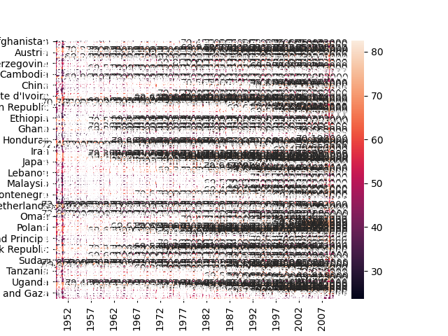

**Code**

import pandas as pd  
import seaborn as sns  
  
df = pd.read_csv("gapminder-FiveYearData.csv")  
#reading the csv file present in the folder  
df2 = df[['country', 'year', 'lifeExp']]  
##taking the columns into an array  
df3 = pd.pivot_table(df2, index='country', columns='year', values='lifeExp')  
## creating a pivot table from the taken data  
print(df3)  
kss = sns.heatmap(df3, annot=True, fmt="f").get_figure().savefig('HeatMap1')  
##drawing the heatmap and fmt refers to formatting value and annot means annotation and savefig is used to save the  
##image in the folder  
  
  
## the image can be seen by using plt.show()

**Explanation.**

1. Read The dataset using read_csv() of pandas.
2. Extracted the requires columns(country, year and lifeExp) from the dataset into a new dataset(df2)
3. Created a pivot table from that data frame (df3) with index=continent, columns=year and values=lifeExp.
4. Heatmap of the pivot table dataframe was plotted using headmap() function of seaborn.

**NOTE**- annot-denotes annotion.

1. The heatmap figure was saved as HeatMap1.png.